Data Mining Assignment 2

Patrick Chase

3/6/2021

# 1.

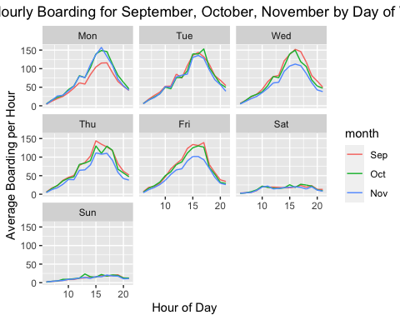

*Plot 1a is showing the average hourly boarding for September, October, and November by day of the week. On weekdays, we see a clear peak around 4:00 pm every day however, on weekends ridership remains relatively flat. A possible reason we see lower ridership on Mondays for September is probably because of the Labor Day holiday that falls on Monday. This caused 1 Monday in September to have drastically lower boardings, thus causing a decrease in it’s Monday’s average for September. Similarly, for Wednesday through Friday in November, we can see a decrease likely because of the Thanksgiving holiday.*

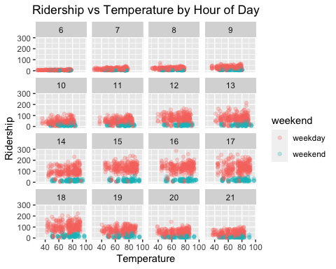 *Plot 1b is showing boardings by temprature controlling for hour of the day and whether it is a weekday or a weekend. When holding hour of the day and weekend status constant, there doesn’t seem to be a clear relationship between ridership and temperature. The fluctuations shown in these scatter plots could just as easily be explained by the normal commuting patterns of students.*

# 2.

## 1 1   
## 66624.01 63106.94

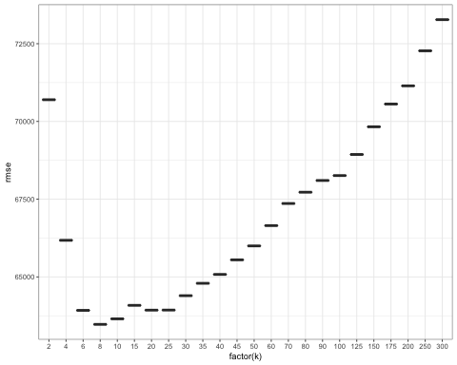

*My model seems to outperform lm_medium by about 5%-6%. That said the KNN model with k = 8 outperforms both by 15%-20%. Depending on the geographic market you’re in, I’d say we need to rely heavily on the location because houses in the same neighborhood are generally going to relatively similar. This is especially true if you’re looking at suburban neighborhoods that were all developed at the same time by the same development company. This strategy would likely have to change if we were in a rural area but we should look at the going rate of similar houses, particularly those that are physical close to the proprety in question, and use that to determine our valuation.*

# 3.

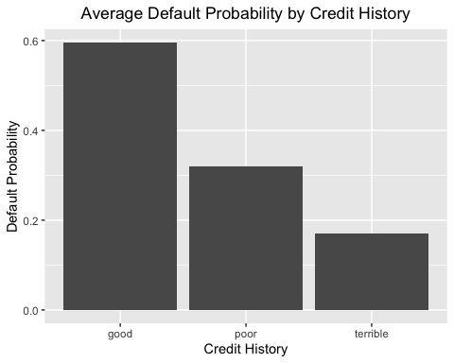

*With this data set, it would seem that the credit history rating is predicting in the exact opposite direction it was originally intended. Those with “terrible” credit history are the least likely to default. This is likely due to sampling bias. If very few individuals with “terrible” credit are being granted lines of credit then in all likelihood the bank has a good reason to give them credit that trumps their credit history. If the bank wanted to improve it’s sampling method, it should be collecting attributes of those it denies credit to as well. This will expand the sample and probably increase the quality of those individuals*

# 4.

## 4.1

## AICs Model  
## 1 13978.44 step_mod2  
## 2 18975.02 small_mod  
## 3 13983.52 big_mod

## 4.2

## 3337 936 704 4782 866 4612   
## -5.28115960 -5.08613624 -5.03432747 -2.74234470 -2.80011739 -1.15347958   
## 4180 1034 2114 2428 3648 3835   
## -0.80081695 -2.18203396 -5.20321329 -5.26942791 -3.71315511 -3.12964587   
## 14 3235 136 1655 799 241   
## -3.16877785 -4.30755421 -6.34465539 -2.66312610 -2.18998536 -24.17670335   
## 222 2061 1777 12 2992 2348   
## -2.96035289 -6.25508342 -1.86978976 -14.76738416 -0.92943926 -3.67285363   
## 1565 4443 963 1051 3323 2112   
## -2.54560352 -2.56323619 -3.71722159 -3.18171531 -4.40545120 -2.63769532   
## 4891 1990 3331 200 3399 1725   
## -2.65659964 0.68156618 -0.73393181 -3.75868771 -4.44427222 -2.39397132   
## 2541 3219 1340 2181 519 3111   
## -3.92300175 -3.71730984 0.36018597 -2.67200314 -3.76062329 -2.87620395   
## 1228 3950 2303 4366 2044 4461   
## -4.19166915 -3.38205329 -3.38887208 -6.05235710 -0.84858200 -2.89718849   
## 2446 2031 788 3029 2499 2553   
## -4.38132031 -3.49988682 -4.64560216 -3.31769821 1.24335508 -6.98450689   
## 1728 1318 4688 1253 3196 76   
## 0.25996901 -3.57361895 -1.64436466 -3.59039515 -4.23715111 -3.64174404   
## 4969 4008 1890 240 2487 648   
## -3.86782756 -2.66438261 -3.01759843 -3.39820319 -3.61997631 -3.63995138   
## 2875 3156 113 4608 3576 1968   
## -5.14623838 -2.78296651 -6.50995381 -4.68850009 -2.98879526 -2.90930394   
## 101 3508 267 498 952 3976   
## -4.90350459 -3.64489702 -3.82803216 -1.68783441 -3.44688232 2.17658607   
## 2645 4920 2299 4241 878 3972   
## -4.36612691 -3.30782895 -2.82675919 -2.44213019 -5.34693798 -5.76003501   
## 4339 1125 83 2616 4875 4505   
## -2.81966881 -2.08929425 -1.01554250 -4.63741826 -2.78123522 -2.75783535   
## 618 3758 3225 3611 204 1823   
## -1.45952285 -3.20193162 -1.79507042 -3.46331681 -2.01746970 -3.59447688   
## 2189 2898 345 2351 841 1092   
## -3.97746394 -3.19676414 -2.13205725 -3.28929781 -4.30576596 -2.45239960   
## 3528 3604 1734 3588 161 99   
## -2.66975458 -2.19527564 -16.09466470 -2.74094725 -2.91495647 -2.82911977   
## 3901 1801 2641 1613 3341 2389   
## -2.90645009 -5.12301106 -3.86995528 -3.32249740 -0.67920325 -2.93644132   
## 391 340 4786 3599 4150 3842   
## -6.29673453 -4.78263698 -3.78844801 -4.28788428 -3.89489497 -2.32584064   
## 3145 1628 4834 3517 3150 1722   
## -2.63143691 -2.55736266 -4.88228042 -3.64938878 -1.62745339 -4.13044672   
## 1192 326 149 2611 1066 2505   
## -3.28311855 -6.82586491 -2.03939428 -3.75344177 -2.43312120 -2.62601990   
## 1414 4693 1834 163 2689 2520   
## -5.47737117 -4.73377269 0.05180186 -2.37929263 -3.05332741 -5.87688541   
## 2804 820 3801 2109 4689 2720   
## -1.95426611 -3.41916507 -2.77118974 -3.35164339 -4.06009049 -2.81364258   
## 1822 4501 3075 3283 1690 4592   
## -2.85533801 -4.22353697 -3.07915969 -2.39631778 -4.84509407 -1.50405039   
## 503 1380 1342 1789 4039 90   
## -7.12024694 -16.20309101 -3.07287219 -3.20796237 -5.21599303 -0.29519650   
## 1116 1129 3043 1038 3360 1385   
## -5.41473736 -5.94319992 -2.37709830 -2.11086870 -1.98903131 -2.66420784   
## 2184 1358 4261 3059 1277 817   
## -2.78960190 -2.49612027 -2.52332212 -1.14513194 -3.36129087 -3.31715395   
## 4074 729 2429 4775 1341 3626   
## -3.15857414 -7.49857178 -5.22137610 -2.65673235 -3.36880271 -4.20603176   
## 3979 4251 3401 88 3571 1093   
## -3.04194989 -4.64777263 -2.80659256 -0.76755304 -4.12821147 -12.48285753   
## 722 4238 1383 3954 753 4176   
## -3.34853972 -2.42261931 -2.64034820 -4.01011596 -2.09224032 -3.55106444   
## 2599 2277 540 4718 951 3458   
## -2.86598766 -0.39773140 -4.11626680 -4.51179158 -1.23517657 -3.71632746   
## 3660 1971 1119 2425 4151 3695   
## -4.17176301 -3.51334249 -0.66180310 -3.04686086 -1.70222643 -2.48708516   
## 1933 4799 2219 1958 3100 1496   
## -3.05042637 -2.81442789 -1.94367613 -3.55287384 -2.65659964 -3.34185431   
## 2531 1367 1820 3383 2827 4701   
## -4.80069279 -2.55369961 -3.99846494 -4.04243838 -2.46354076 -3.91343587   
## 3128 3144 4056 1833 4122 1028   
## -4.63216630 -2.46490783 -1.99666492 -2.71151642 -3.43645845 -4.03890165   
## 3918 2677 3467 3444 4952 2730   
## -2.01365718 -2.03371444 -2.04068956 -2.98114001 -5.90840855 -1.85395206   
## 3306 2831 311 3404 2260 3688   
## -1.08086423 -5.77784834 -7.71198345 -4.91236911 -2.27641837 2.06938484   
## 1356 4953 4935 1484 218 2417   
## -17.40129408 -3.32449961 -3.16781342 -3.21545906 -3.73156677 -3.06030888   
## 257 2462 1961 564 1156 1641   
## 0.19696009 -3.36520532 -2.73803651 -6.18330467 -1.59139706 -2.81985036   
## 4616 1939 2232 317 447 4307   
## -3.10306749 -5.30352767 -4.19606525 -2.51658396 -2.80843043 -5.09550679   
## 4146 941 2066   
## -3.30148157 -4.76782507 -2.32852178

## 3337 936 704 4782 866 4612   
## -5.281160 -5.086136 -5.034327 -2.742345 -2.800117 -1.153480

*So I’ve tried this a bunch of different ways and I haven’t been able to figure out how to arrive at the asked for outputs. After consulting with Rui, I’m pretty sure I’ve done the 20-fold validation correctly but I’m not sure how to move from that into a neat table to get the predicted values, summed probabilities, and the actual bookings into a neat table.*